Exercise Sheet 1

For each of the following problem definitions :

1. Identify the major classes present
2. Identify their most important operations and properties
3. Construct a class diagram showing any associations and aggregations
4. Construct interaction diagrams showing interactions between objects
5. A person, identified by a unique identification number and a surname can own one

vehicle at a time. . A vehicle is given a maker’s name and a registration number.

In addition a person must also be able to disown a vehicle and should be able to display the details of the vehicle owned..

*Show how a person could own a vehicle, display its details and then disown it.*

*Show how the same person could own a different vehicle and then display its details.*

*Will be on exam*

Q2 A country has many cities. Each city has a name and a population, while a country has a name and a capital city . It is a requirement that a country should display , on request, its capital city through the operation displayCapital? as well as the names of all of its cities through the operation displayCities?. In addition , it should display the total population of the country through the operation displayTotalPoulation? It should also display the average city population through the operation displayAveragePopulation?

*Model this system showing how the capital city, the names of the cities and the average city population of a country should be ascertained.*

*Country*

*City*

*Cityname*

*City population*

*Country name*

*Country capital city*

*1st model*

*Country (name, capital city) <>-----------------------\* City (name, population)*

*2nd model*

*Country (name) <>--------------------------\* City (name, population)*

*<> ------------------Capital City;*

*What mapping strategy would you use to map this to java*

*Country would have a name and a capitalciyt City object attribute which is reference to capital city. It would also have a collection attribute of cities*

*Navigability – Direction in which relationship can be traversed (country to city is unidirectional)*

*Multiplicity - How many instances of one class are linked to another class*

*Country should handle displayCapital() method*

*Country City*

*---------------------------🡪 | |*

*Displaycapital() | |*

*|----------🡪 |*

*getName()*

*Country City*

*---------------------------🡪 | |*

*Displaycapital() |[more cities] |*

*LOOP |----------🡪 |*

*getPop()*

*Getters needed because of data hiding, private attributes can only be accessed by a public interface.*

*Immutable attributes – cannot be changed. Only set in the constructor. Normally identifying attributes (ID number).*

*Reference attributes build relationships.*

*Collaborator. If a class has a responsibility, does it need another class to fulfil that responsibility? If so then that class is called the collaborator.*

*CRC – Class responsibility collaborator*

*Model – Entity classes(Design classes), Persistent -> Persistence mechanism(dbms)*

*View -*

*Controller -*

*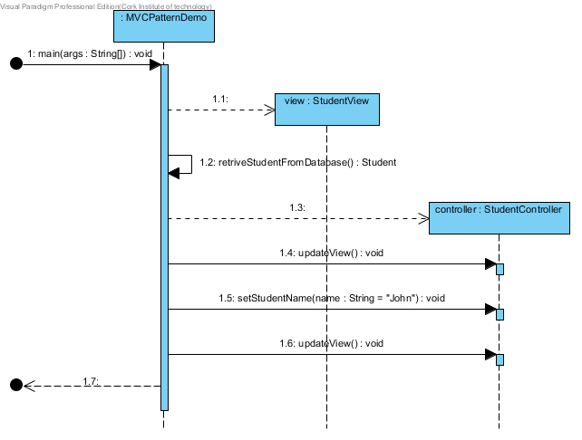*

public class MVCPatternDemo {

public static void main(String[] args) {

//fetch student record based on his roll no from the databaseStudent model = retriveStudentFromDatabase();

//Create a view : to write student details on console

StudentView view = new StudentView();

Student student = retriveStudentFromDatabase();

System.out.println(student.getName());

StudentController controller = new StudentController(student, view);

controller.updateView();

//update model data

controller.setStudentName("John");

controller.updateView();

}

private static Student retriveStudentFromDatabase(){

Student student = new Student();

student.setName("Robert");

System.out.println(student.getName());

student.setRollNo("10");

System.out.println(student.getRollNo());

return student;

}

}

*Explain the relations ships in the class diagram*

*Navigability. One way, view doesn’t know about the controller but controller knows about the view.*

*Class scoped operation = static method = underlined*

*Composition (+) means an inner class*

Q3. A bank has a name and a number of accounts each of which has a name and reference number of the account holder as well of the current balance. An account holder can make a deposit to a specified account or withdraw a specified amount. The following operations are to be supported.

1. making a deposit
2. making a withdrawal
3. displaying account details
4. making a withdrawal with a check that sufficient funds are available.
5. making a withdrawal with an overdraft facility

Q4 A teaching block consists of several rooms each with a unique room number and specified seating capacity. Rooms may be booked on a particular day for lectures. Each booking must start on the hour and can be of any duration. It must be possible to book a room in the teaching block if it is free and generate a display of the status of each room in the teaching block if it is free and generate a display of the status of each room in the teaching block for a particular day.